Part 1:
Instructions
Please provide short answer explanations to the questions down below. Include C syntax where noted.
- Define a structure and identify its parts providing a syntax example.
- How is a structure initialized and accessed. Please provide a syntax example.
- Define the keyword typedef and explain how it can be used?
- What is a union and how can it be used?
- Explain and provide an example of a bitwise operator.

Part 2:
Instructions
Open your Visual Studio 2015 XenDesktop image, create a new project, and type the coding segments down below into the source file. Run the program(s) (Debug > Start without debugging).
- Execute the following code and identify the errors in the program. Debug the program and provide the correct version of the code.
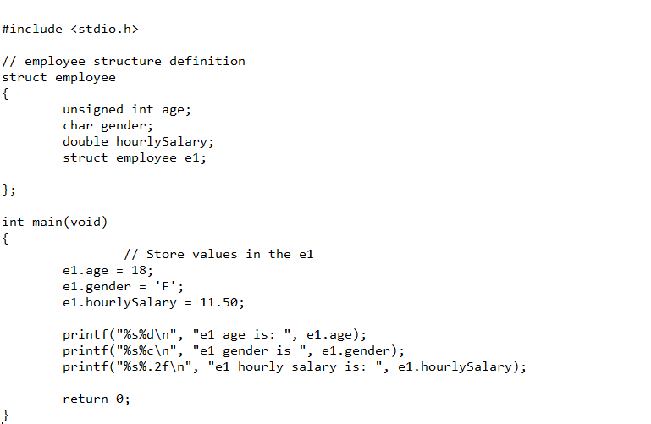
- Execute the following code and identify the errors in the program. Debug the program and provide the correct version of the code.
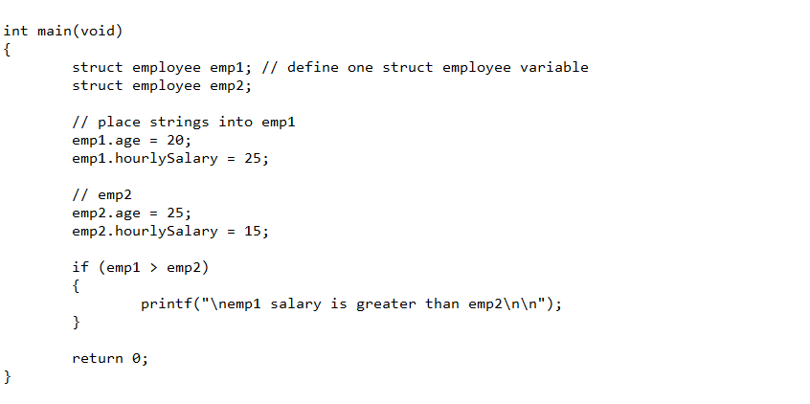
- Execute the following code and identify the errors in the program. Debug the program and provide the correct version of the code. Note: Be sure to check the output screen to see if the correct values are displaying according.
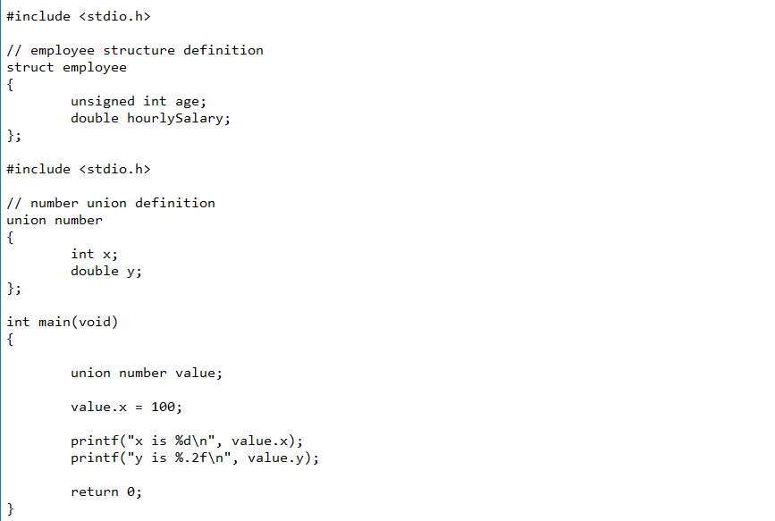

- Execute the following code and identify the errors in the program. Debug the program and provide the correct version of the code. Be sure the output looks exactly like the screen shot below.
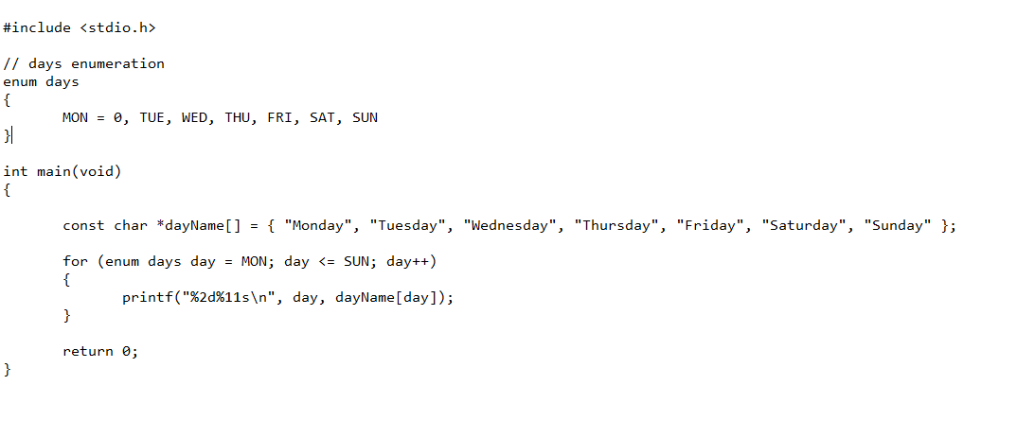
- Execute the following code and identify the errors in the program. Debug the program and provide the correct version of the code.
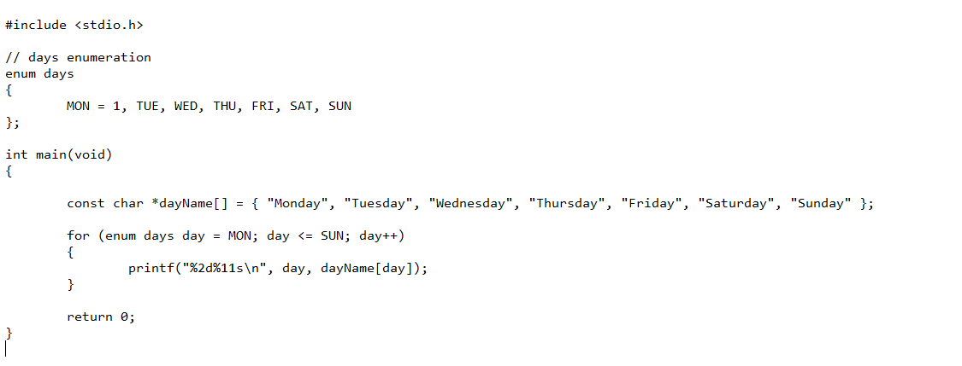
Submission Instructions
Upload a Microsoft Word Document with your answers to the questions in Part 1 and your written explanation of the error(s) and revised code for Part 2. Use this naming convention to name your Word Document:

